Assessment Schedule – 2014
Physics: Demonstrate understanding of wave systems (91523)
Assessment Criteria
Achievement | Achievement with Merit | Achievement with Excellence
Demonstrate understanding requires writing statements that typically show an awareness of how simple facets of phenomena, concepts or principles relate to a described situation. For mathematical solutions, relevant concepts will be transparent, methods will be straightforward. | Demonstrate in-depth understanding requires writing statements that typically give reasons why phenomena, concepts or principles relate to given situations. For mathematical solutions, the information may not be directly useable or immediately obvious. | Demonstrate comprehensive understanding requires writing statements that typically give reasons why phenomena, concepts or principles relate to given situations. Statements will demonstrate understanding of connections between concepts.

Evidence Statement
Q | Evidence | Achievement | Merit | Excellence
ONE  (a) | L = ¼ λ = ¼ × 2.6 = 0.650 m | - L = λ/4 or λ = 4L  - 0.650 m
(b) | - The wavelength of the standing sound wave forming in the pipe must allow a position of permanent constructive interference (antinode) to occur at the open end. There will be a position of permanent destructive interference (node) at the closed end because the waves reflect back out of phase/particles can’t move.  - The sharp lip generates sound waves that have a large range of different frequencies, and some of these will produce a wavelength (length of the pipe is an odd number of quarter λ) that will meet the condition above.  Answers can describe wavelengths that don’t meet conditions not creating standing waves | - Wavelength must ‘fit’.  - There must be a node at the closed end of the pipe.  - There must be an antinode at the open end of the pipe.  - Driving frequency equals the natural/resonant frequency.  - Only odd harmonic frequencies will produce standing waves | - Position of node and antinode linked to type of interference occurring.  - Only frequencies that create waves of the correct length to place a displacement node at the closed end and an antinode at the open end will form standing waves.  - L must be equal to an odd number of quarter wavelengths  OR λ=4L/(2n-1) or equivalent | - Answer that only those frequencies that create waves of the correct length to place a displacement node at the closed end and an antinode at the open end linked to why the type of interference that is permanently occurring at these positions occurs.
(c) | - The length of the pipe is proportional to the wavelength of the sound wave produced.  - As the frequency (pitch) of the sound produced depends inversely on its wavelength (v = fλ), the longer the pipe the lower the frequency. | - Longer pipes produce longer wavelengths of sound.  - Longer wavelengths have a lower pitch / frequency.  - Pipe length affects / changes the wavelength which affects the frequency / pitch. | - Pitch of the sound linked to the wavelength and the length of the pipe.
(d) | - 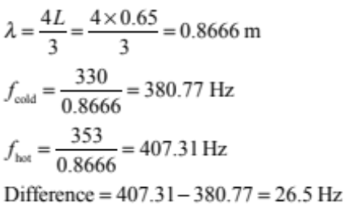 | - 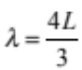  OR  - Diagram drawn correctly for the 3rd harmonic.  - Correct frequency for any odd harmonic using L = 2.6 or consequential from 1(a). | - One correct frequency found (380.77 or 407.31 Hz).  - Correct working and answer for the 5th harmonic (44 Hz).  - Correct answer using L = 2.6 m or consequential from1(a). | - Correct working and answer:  26.5 Hz (accept 26 or 27 Hz if rounded too soon).

Q | Evidence | Achievement | Merit | Excellence
TWO  (a) | 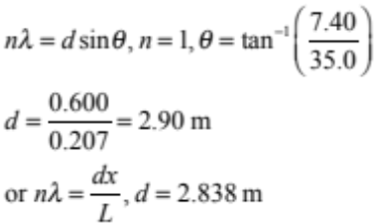 | - 2.84 m  - d sinθ = n λ used with any angle | - 2.90 m
(b) | There are positions along AB where the waves from each slit arrive in phase with each other. This occurs when the path taken by two waves differs in length by a whole number of wavelengths.  Between each position of constructive interference, there are positions where the waves arrive with opposite phase. This occurs when the path taken by two waves differs in length by an odd number of half wavelengths. | - If the path difference is a whole number (of wavelengths), the interference is constructive.  - If the waves to arrive in phase, there will be constructive interference, and if they arrive in opposite phase, there will be destructive interference. | - Explanation links phase difference to path difference and resulting interference for both loud / quiet positions. (ie n λ = PD for constructive and (n – ) λ=PD for destructive).
(c) | As x is inversely proportional to d, the positions of constructive interference (loud places) will be further apart, and there will be fewer of them. | - Fewer loud positions.  - Loud positions further apart. | - Reduction in speaker separation causes increase in distance between positions of constructive interference explained with reference to relevant formulae.
(d) | - The positions of constructive interference would be different for different wavelengths, so different notes would be heard at different positions.  - At the central position, all frequencies experience constructive interference, so a composite note would be heard.  - Because the positions of constructive interference depend on sinθ, the lower frequency (longest wavelength) sounds would be heard further apart. | - All sounds equally loud in the centre.  - Different frequencies become loud as you walk along the line.  - Each frequency has different distances between nodal and antinodal lines.  - More places where there are loud points / constructive interference. | - Each frequency heard at several positions.  - Comparison made between single pitch / frequency heard in (b) and each frequency heard in different locations.  - First order of constructive interference has highest to lowest frequency from the centre moving out. | - Explains that several interference patterns cause loud sounds of different frequencies to be heard in different positions.  - Explains that the positions of constructive interference will be more widely spaced for lower frequencies / longer wavelengths.

Q | Evidence | Achievement | Merit | Excellence
THREE  (a) | 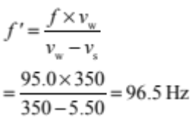 | - 96.5 Hz
(b) | Because the source is moving towards the observer, each time a wave front is emitted, the source is slightly closer to the observer than when it produced the previous wave front.  The waves are therefore slightly bunched together, shortening the wavelength and so increasing the frequency.  Increased frequency means a higher pitch. | - Shortening of the wavelength / bunching of the waves in front of the moving source described.  - Source is moving relative to the observer.  - Source is moving relative to the waves. | - Shortening of the wavelength correctly explained in terms of relative motion / movement of the source between the creation of each wave / each wave being created in a different position and linked to the increased frequency heard by the observer.
(c)(i) | 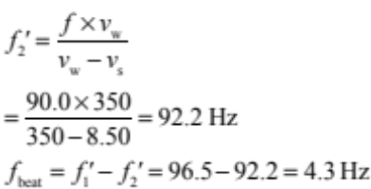 | - f_{beat} = f₁ – f₂  - Correct calculation of Doppler shifted frequency of second boat can be used as replacement evidence for 3(a). | - Correct answer.
(ii) | Beats are the regular variation of the loudness of the sound heard.  For beats to be heard, two sound waves having slightly different frequencies, must reach an observer.  The slight difference in frequency makes the phases of the two waves, when they reach an observer, vary in a regular way, between in phase and opposite phase.  In phase waves are relatively loud, opposite phase waves are relatively soft, so the sound heard varies regularly between loud and soft. | - Beats described as the regular variation of the loudness of the sound heard.  - Answer implies that beats occur because of the difference in frequency of the two notes.  - Beats are caused by interference / superposition of waves from two sources. | - Beats are a variation of the amplitude / loudness of the sound heard due to constructive and destructive interference over time.  - Beats are a variation of the amplitude / loudness of the sound heard caused by waves arriving in phase and then out of phase alternately. | - Explanation shows clear understanding that beats are caused when similar frequencies of wave interfere. The combined waves heard by a fixed observer change in amplitude regularly over time as the waves move in (loud) and out (quiet) of phase and the interference alternates between constructive and destructive.

Q1 | N0 | N1 | N2 | A3 | A4 | M5 | M6 | E7 | E8
Q1 | 0A | 1A | 2A | 3A | 4A | 2M | 3M | 1E | 2E

Q2 | N0 | N1 | N2 | A3 | A4 | M5 | M6 | E7 | E8
Q2 | 0A | 1A | 2A or 1M | 3A | 4A | 2M | 3M | 1E | 2E

Q3 | N0 | N1 | N2 | A3 | A4 | M5 | M6 | E7 | E8
Q3 | 0A | 1A | 2A | 3A | 4A | 2M | 3M | 1E with one minor error | 1E

Cut Scores
 | Not Achieved | Achievement | Achievement with Merit | Achievement with Excellence
Score range | 0 – 6 | 7 – 12 | 13 – 18 | 19 – 24

